# We wish to formally oppose and strongly disagree with the Draft Local Plan to remove the green belt in the area on School Road, Hockley Heath B94 6RA to provide a site for housing development. We also formally oppose and strongly disagree with the washed over green belt on School Road, Hockley Heath   B94 6RA being removed which may result in two further plots being developed for dwellings in the future.

Mr Saqib Bhatti tweeted on twitter 2 weeks ago

“Today I asked the Prime Minister to commit to doing everything he can to protect our precious Green Belt which is so important to me and my constituents.

We must make sure we are building on brownfield sites first to protect our beautiful countryside. 🌳”

* As of 12th. October 2020.there are 102 sites on Brownfield Land Register (solihull.gov.uk)

# Why are these sites not being utilized for development?

* As of 12th. October 2020. There are 42 properties for sale At Blythe Gate, Blythe Valley Park (a new build development in the local area) ( ref – <https://www.zoopla.co.uk/for-sale/property/blythe-valley-park/?identifier=blythe-valley-park&page_size=25&q=Blythe%20valley%20park%20b90&search_source=refine&radius=0.25&view_type=list&pn=3>

Plus, other various properties are for sale in the local area.

Do we really need more housing in the area?

* Due to over building and loss of green belt in the area water displacement is a real and dangerous problem

Watch: Amazing moment man goes for a swim on the Stratford Road

<https://www.birminghammail.co.uk/news/midlands-news/watch-amazing-moment-man-goes-14715705>

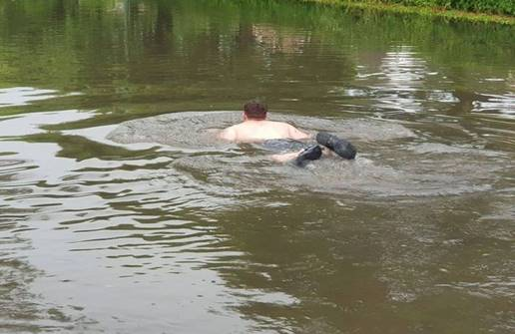

* This does not just happen now and again but every time it rains.
* The impact on the local enviroment is plain to see.
* What wildlife will be lost due to a lack of natural habitat.
* A few extra planted trees will not cover all the green belt due to be lost.
* Once this area is built on there is no going back.

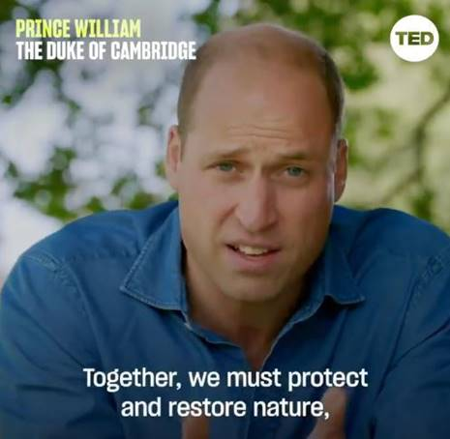

Explaining how now is the time for businesses and governments to look at how they do things; making the world a greener place, the duke said: “Someone has to put their head above the parapet and say, I care about this. To have the belief that if we all work together, we can make a difference."

* From approximately 16.30 until 18.30 every day there is a line of traffic outside my property waiting to turning onto the Stratford Road. The main Stratford Road cannot cope with the traffic levels at present. Extra housing = extra cars = more congestion. What is in place to combat this very worrying situation?
* What measures have Solihull Council put in place for extra capacity on local roadways
* What measures have Solihull Council put in place for extra capacity in Schools in the area?
* What measures have Solihull Council put in place for extra capacity in Doctors and health care?
* What measures have Solihull Council put in place for extra Police and other service?
* Or do we as Solihull council taxpayers and resident of Hockley Heath have to accept substandard services?
* This removal of green belt is an atrocious lack of care for local community and environment.
* **It is purely for profit.**