Supporting Notes and Photos by Phil Brown.

Figures 1-3 show the existing hedgerow along School Road on the South Side, the land behind the hedge has already been cleared of further hedges and shrubs that provided a better environment for wildlife.

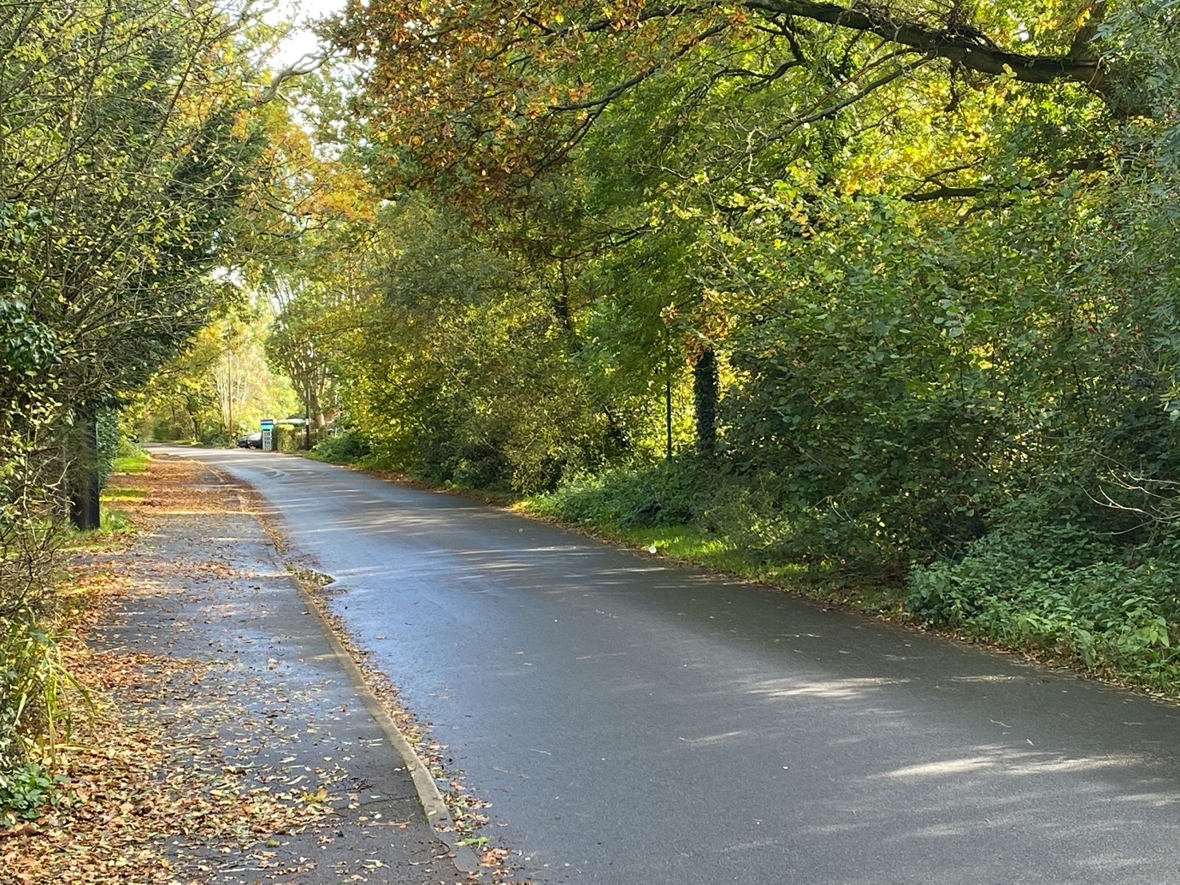
Figure 1 - Looking towards the School from just beyond Saddlerswell Lane
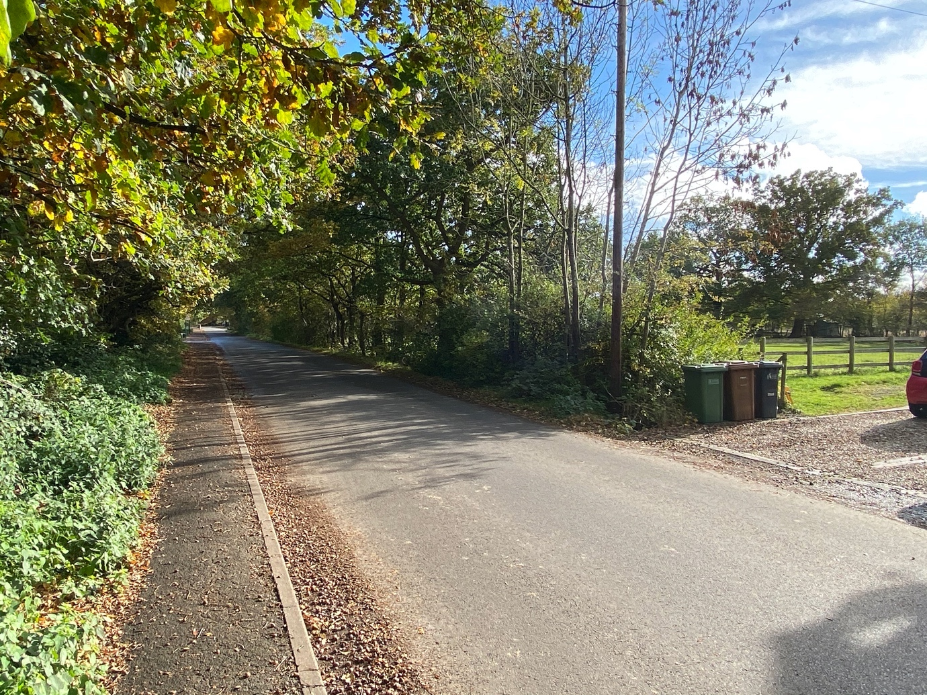
Figure 2 - Looking towards the School from the Cottages in School Lane.

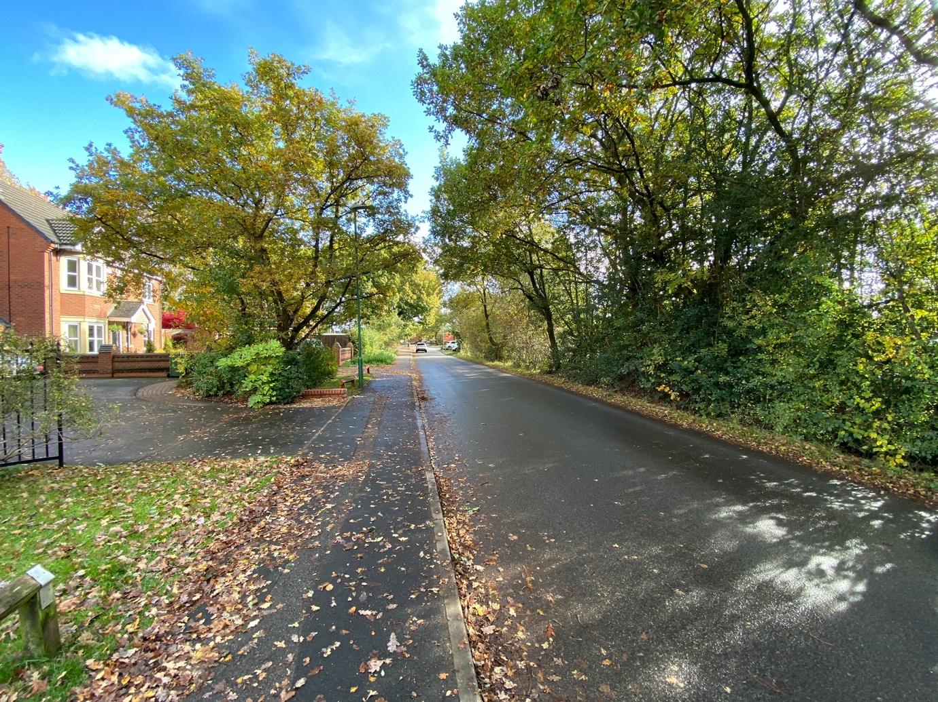
Figure 3 - Looking towards the School in the vicinity of the Proposed Access Road into the development
Figure 3 also shows the current location, on the North side of the road, that is popular with parents parking to drop/collect children to/from the school. At this point it is relatively safe as the School is only a short walk and is on the same side of the road, without the need to cross any roads.

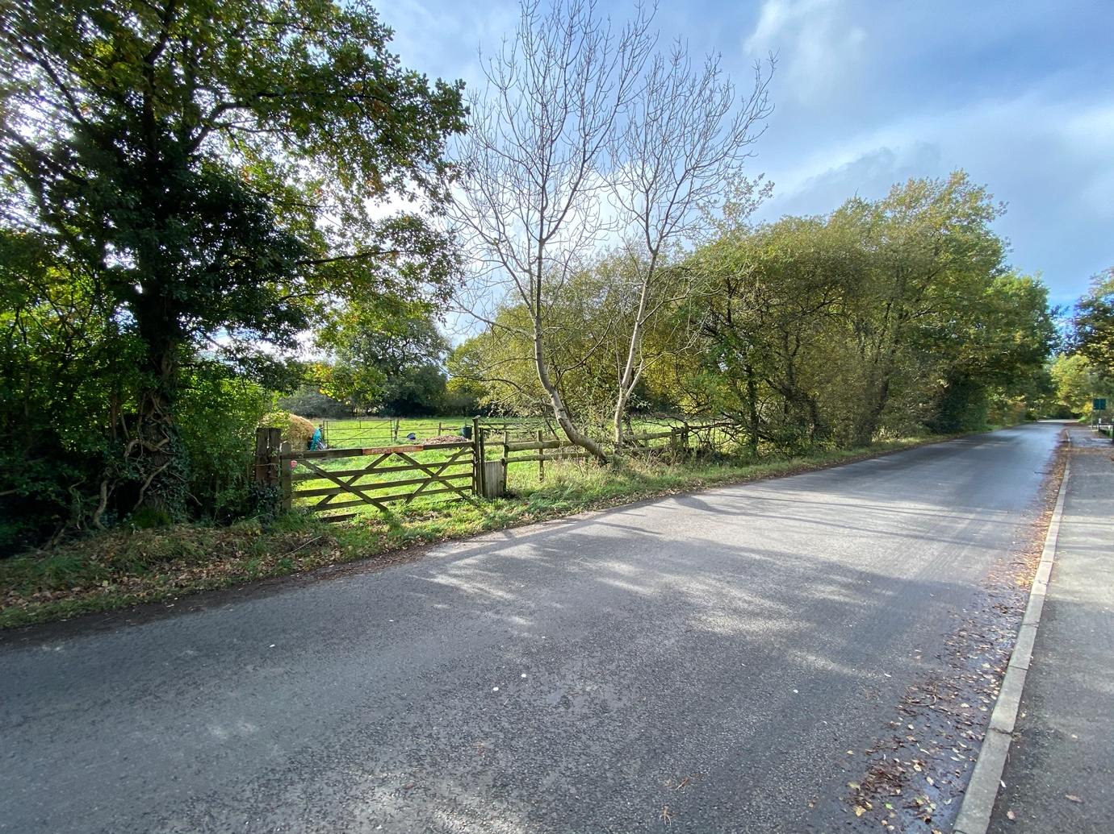
Figure 4 - Looking away from the School in the vicinity of the proposed Access road to the development.
Apart from this area (shown Figure 4) and the Cottages, the hedgerow, including some mature trees, including Oak, is continuous from the houses opposite the School to the junction of Saddlerswell Lane, and then round into Saddlerswell Lane itself and to the canal bridge.

Beyond the junction with Ashford Road, School Road becomes narrower, and takes the form of a “typical country lane”. The traffic has been increasing for years, but with the development of BVP (700+ homes), what will the extra traffic do to the road, which is unsuitable for the bigger vehicles, including the increased van traffic caused by online shopping. There have been no traffic studies, to my knowledge, that has reviewed this impact, such that suitable modelling for the impact of additional vehicle journeys generated by the proposed new developments around the School end of the road can be assessed.

Additionally, School Road remains flooded for most of the year, such that the temporary flood signs have remained on location for the last 18 months at least. If the proposal is to make the road more suitable for cyclists, or walking, is that a proposal to resolve the flooding issues? A cyclist can ride through and get wet, but a walker cannot pass without suitable footwear.

Figure 5 shows this location, with the sign. This also shows the “Country lane” aspect of School Road beyond the Ashford Lane junction
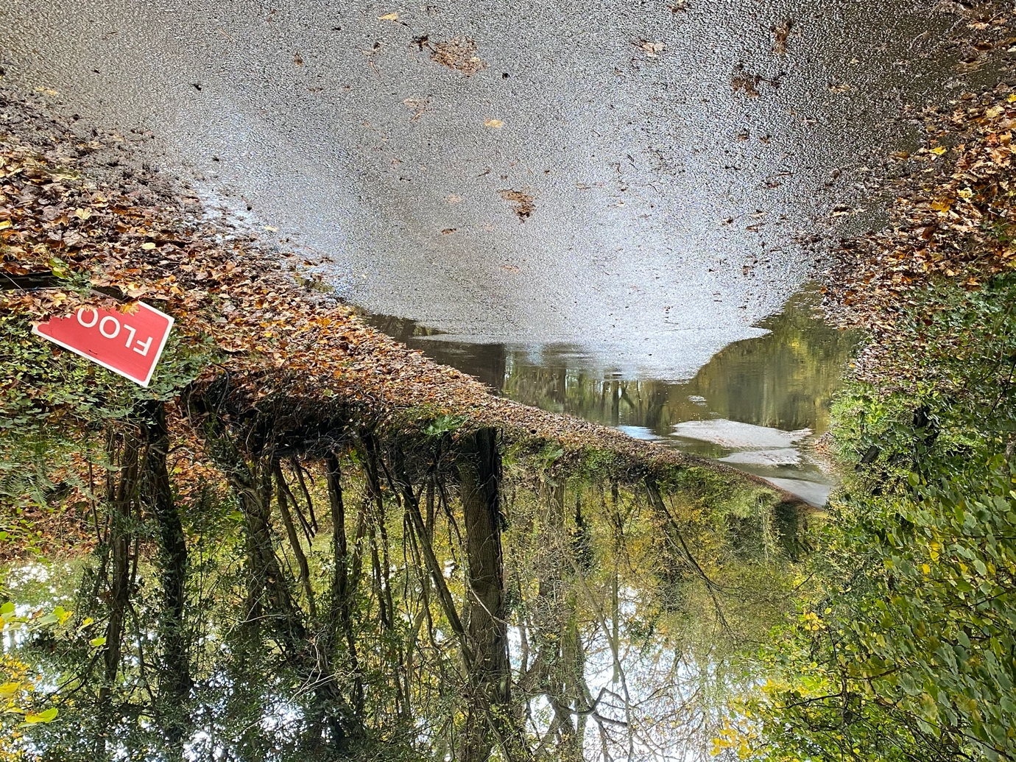
Figure 5 - Flooding in School Road - Looking in the direction of the School.

The footpath along School Road, when walking away from the village centre, ends before the junction with Saddlerswell Lane. Is there any plan to extend this to increase walking potential as outlined in No. 666. It is not made clear the extent of the plan. Equally other than a single lamp in the vicinity of the Cottages, there is no street lighting beyond Tuttnal Drive, making it a very dark road to walk along on a Winters Evening. It may be argued this is part of the character of the road currently.

Policy HH1 Section 2 point ii. suggests that “Retention of Trees and Hedgerows to conserve the semi-rural character of School Road and Saddlerswell Lane”
Who will enforce/manage that this policy is adhered to? The same Policy existed at Mount Dairy Farm, with the recent developments there. The circumstances of land layout were very similar, with natural lines of existing hedges and mature trees. The resultant development has maintained a token of what existed, albeit without loss of mature trees, but it will be of little value to the wildlife that needed the continuous run of hedgerow to both feed and seek out new mates from differing populations. A short run of tress with hedge, which is not connected to another is not what nature needs, although I accept it is better than no trees or hedge at all. Figure 6 shows a former hedgerow, that has been truncated to meet the needs of the development at Mount Dairy Farm.

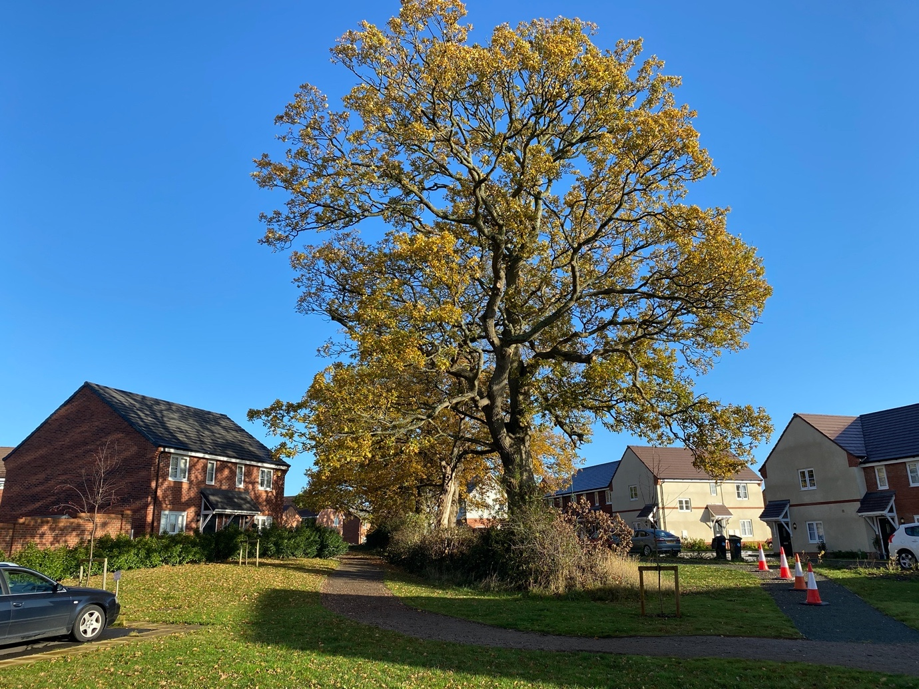
Figure 6 - Hedgerow in the Mount Dairy Farm development.

The canal provides the “Natural Boundary” for these proposals, probably because land beyond is part of Stratford Council, however this boundary also needs protecting for both is existing rural aspect, but also for its wildlife support. It has been a feeding area for Kingfishers, for a number of years, and these birds need a quiet environment to fish, and support young. The development proposes both a play area adjacent to the canal boundary and also more access onto the canal for walkers presumably. The former would provide an unnecessary increase in noise, while the latter could be provided by simply improving the access point in Saddlerswell Lane. Increasing the number of breaks in the hedgerow should be avoided, for the benefit of nature. Also, the canal footpath along this section between bridge 24 (Saddlerswell Lane) and The Wharf is unpassable for many months of the year, without specialist footware, as it is liable to flooding in many places. Who is going to fund the improvement works required to make it a suitable and safe walking route? There is no mention of this works in the plans.

Figure 7 shows a section of mature Canalside, prior to the towpath becoming impassable.

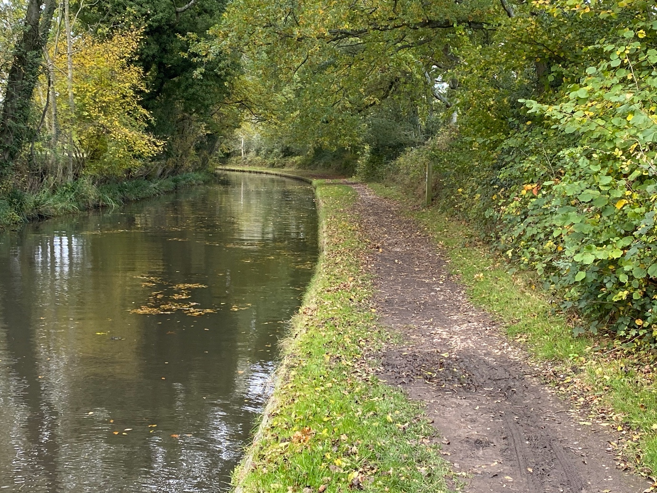
Figure 7 - Sample View showing Canal Hedgerow looking in the direction of Saddlerswell Lane (Bridge 24)

