Response to Solihull Local Plan- Draft Submission Plan October 2020
The Parish Council, in conjunction with representatives of Catherine de Barnes Residents Association, wish to object to two elements of the Draft SMBC Local Plan;
- The nature of the potential development on Site Policy HA2 and
- The inclusion of Site Policy SO1 (site East of Solihull) in the Plan.
Our comments are based on aspects of the reasoning in, and presentation of, the Plan which we think makes aspects of it;
- unsound,
- inconsistent with earlier SMBC analyses, and
- In parts misleading.
We detail our concerns and objections below:
1. Policy HA2 (known as Site 196 in SHLAA 2012) Page 184 Hampton in Arden
The site is allocated for 95 dwellings, but it is also recognised that it would be suitable for ‘Housing for Older and Disabled People’ (Policy 4e use).
However, the SHLAA Site Assessments made in September 2012, concluded that the site was not suitable for family housing, mainly because of poor accessibility to schools (see Appendix A).
We suggest the site continues to be unsuitable for family housing as the conditions observed in 2012 still exist. No new schools have been provided locally, no footpaths have been laid to improve pedestrian access and no new infrastructure exists to improve the conditions from how they were back in 2012. The site is poorly served by public transport. There is an hourly bus service to Solihull/Coventry operating from appx. 7.00pm to 7.00pm Monday to Saturday but there is no service on a Sunday.
We recognise that a self -contained facility, such as a care home/village, could be accommodated without significantly impacting on local facilities.

2. Policy SO1 East of Solihull (Known as site 16 in the LPR2019) pages 186 and 213
Firstly, we wish to comment on the location of the justification text within the document:
Although a small reference to the site is made within the Hampton-in-Arden section of the Plan (Page 186 Para 651), the site itself is dealt within the Solihull Town Centre & Mature Suburbs section of the Plan. This is inappropriate. The site in its entirety sits within the Parish of Hampton-in-Arden (and specifically the Catherine de Barnes Ward). Irrespective of how SMBC wish to categorise the site, its inclusion in the Solihull section of the Plan is misleading and does not truly reflect the impact of the Plan on the Parish and specifically the Catherine de Barnes Ward. Our parish ratepayers are not going to understand how a major housing proposal is not considered relevant to the people within the Ward in which it is situated. As Precept payers, they may well feel disenfranchised by this presentation.
Secondly, we have several concerns about the proposal itself, and comment below on the various paragraphs under the heading Justification (page 214).
The site SO1 was included in earlier Draft Review Plans but not in the form it appears today. The site originally comprised a number of smaller sites which, individually, were considered for inclusion in the Plan in 2013. Following the SHLAA assessment in 2012, SMBC decided not to include these sites in the Submission Plan document and they were excluded from the Adopted Plan of 2013. The details and conclusions reached for the individual sites is included in Appendix B and we suggest that the reasons for their exclusion are as valid now as they were then.
Para 804: We take exception to the statement made here that ‘This allocation takes the form of an urban extension close to Solihull Town Centre’. The site is around 2km from Solihull Town Centre and less than 1 km from Catherine de Barnes. The site is located on the eastern side of Damson Parkway and northern side of Hampton Lane which is now a ribbon development. Currently there are around 400 dwellings in Catherine de Barnes Ward, so a development of 700 dwellings represents a housing increase of around 140%. This will have unacceptable impacts on local facilities and environment.
Para 805: This paragraph refers to the allocation as a continuation of the existing development area. We cannot agree with this conclusion. Had the allocation not crossed the current ‘defensible boundary’ of the Damson Parkway we would accept this conclusion. The fact that the site crosses the existing boundary which at the time was defined as ‘defensible’ represents a major incursion into the Green Belt and sets a significant precedent for its future further erosion.
Furthermore, in January 2019 SMBC included an extension of the previous boundary, which was from Lugtrout Lane north to the Grand Union Canal. The intention was to establish a small estate for around 50 dwellings on the extended area. As things stand today, all the development along the length of Lugtrout Lane is ‘ribbon type’. Attempts to develop any site along Lugtrout Lane so far have been refused on the grounds of ‘inappropriate development in the Green Belt’. In fact, as recently as 2018 and 2020, two applications, one for ribbon type development and the other for 8 self- build houses, were refused (See Appendix C for full details). We consider the grounds for opposing these developments given in 2018 and 2020 can validly be applied to this entire extension strip.
The comment in Para 805 that the site is ‘lower performing’ when measured against the four Green Belt purposes is, we believe, inaccurate. Referring to the Solihull Green Belt Assessment 2016:
- Purpose 1: To check the unrestricted sprawl of large built up areas. This green field site does perform function 1 and should be marked at least 2, possibly 3, rather than the 1 in the Solihull Green Belt Assessment 2016
- Purpose 2: To prevent neighbouring towns merging into one another. The site assessment recognises that the site is more moderately performing against this purpose and marks it 2. Due to its location we believe the site is higher performing and warrants a 3.
- Purpose 3: To assist in safeguarding the countryside from encroachment. The Green Belt Assessment concludes that the site is lower performing in this area but the position of the site, surely, at least moderately performs this purpose and in doing so warrants a mark of 2. (The Solihull Borough Landscape Character Assessment December 2016 says that the sub-area provides access to the wider countryside for recreation and serves as a buffer to protect the merger of Solihull with Catherine de Barnes and Hampton in Arden further east. We agree with this)
- Purpose 4: To preserve the setting and character of historic towns. We agree that the site does not contribute to this purpose and agree with the mark of 1.

On the basis of the marking we believe more appropriate for the site, i.e.7 possibly a 9, the site ought to be categorised as at least moderately performing if not highly performing. See also our comments on Para 807 below.
In addition, the SLP Submission document details a number of challenges and objectives. One of these is Challenge E with the associated Objectives detailed below:
Challenge E - Protecting key gaps between urban areas and settlements
- Maintaining the integrity of the Green Belt and the Borough’s attractive rural setting that helps to attract investment, in the context of the significant pressures on agriculture and for development to meet the housing requirements for Solihull including the local and wider Housing Market Area needs.
Objectives
- Maintain the Green Belt and improve the network of green infrastructure in Solihull, to prevent unrestricted expansion of the major urban area, to safeguard the key gaps between settlements such as the Meriden Gap and the countryside.
- Ensure that the countryside is managed so as to deliver a range of benefits including the growing of food and energy products, create an attractive rural setting and improved public access and recreational opportunities.
We suggest that these objectives are clearly not met by development on site SO1.
The site is prime agricultural land, being farmed on a daily basis and should be protected as such. SMBC’s own Ecological Assessment (dated December 2019) recognises at Fig 4 Phase 1 Habitats that the development parcel remains rural with intensive farmland, with 37.5% improved grassland and 19.4% arable land. It also includes ‘better quality habitats’ such as 6.6% broad-leaved semi-natural woodland, 14.7% poor semi-improved grassland and 1.4% broad-leaved plantation. This is quality Green Belt that should not be sacrificed.
Para 806: Whilst the site is in close proximity to the nearest primary school, that school is currently over committed. The nearest secondary school, which is at full capacity, is nearly 1400 metres away (beyond the recognised walking distance of 1200 m) with no direct access by public transport requiring two bus journeys.
Para 807: We refer to Solihull Borough Landscape Character Assessment dated December 2016 Sub Area 1a. The Plan states that the area, on the fringe of Solihull, has a medium landscape value and medium overall sensitivity to new development. However, according to the SMBC Landscape Assessment, ‘the area would typically have an overall low landscape capacity to accommodate change’ and goes on to say that any new development should not result in the merger of Solihull and Catherine de Barnes.

The inclusion of Site SO1 within the Plan therefore contradicts these other recent assessments.

Traffic Impacts
We do not feel the traffic impacts of this proposed development has been sufficiently thought through.
The East of Solihull Site is likely to have two vehicle access points, one, 50 metres from the junction with Damson Parkway on Lugtrout Lane, a small country lane, and the other, off Damson Parkway opposite the Shire Hospital complex/Rayner House Yew Trees, a combined residential care home with assisted living and day care. This road already experiences severe traffic issues during peak times as it’s a main employee route to JLR, to the NEC and the Airport from southern/western Solihull. The site exiting on to Damson Parkway is approx. 250 metres from an already heavily trafficked junction with Warwick Road.
In addition, a new giant JLR logistics centre is currently under construction further up Damson Parkway. This, together with a new waste facility being planned on Damson Parkway - (Policy P12 page 108 bullet 7 refers) will significantly increase the traffic on Damson Parkway which provides the main thoroughfare for traffic from the southern and western parts of the Borough to the Airport, Resort World. We are not confident that this has been taken into account by any Traffic Impact Assessment. Consideration should also be given to
- the potential Brexit Lorry Park
- the Arden Cross Development and that
- Any closure to the M42 link with the M6 can see traffic diverted into the area.
In addition, Damson Parkway is one of the designated routes for the SPRINT rapid bus- strategy. SPRINT is a bus rapid transit (BRT) service that delivers predictable journey times and high frequency, dependable timetables. A commitment to bus priority is required for SPRINT to achieve its primary aim of increased journey reliability. In some cases, reallocation of road space has been considered so that SPRINT and other bus services can avoid long delays as a result of congestion, with minimum impact to local residents. The route envisaged is shown in the fig below.
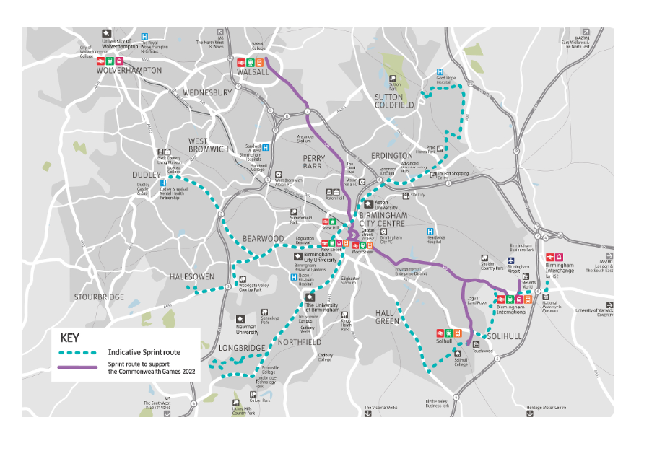Damson Parkway represents a major West Midlands Employment and Growth Corridor, which is going to put some of these routes under severe traffic strain, see map at Appendix D.

Housing trajectory
We also have some issues with the points made on Page 69 of the Plan, Para 224, and specifically, to the highlighted part of the text which refers to the delivery trajectory of sites. It states;
‘To ensure that an adequate supply of housing will be available throughout the plan period, consideration has been given to the likely delivery rates of both existing commitments and the proposed allocations over the plan period. A number of small-medium sites will gain permission and commence development within the first five years of adoption of the plan from 2021, however, some of the larger sites will not make a significant contribution until the mid-delivery phase.’
There is no evidence within this Plan to support this statement. All but one of the larger sites, consisting of over 300 dwellings, are destined to start in the 1st Phase extending into the 2nd Phase; there is no evidence of the scheduling of delivery through this period. We have assumed, reasonably we hope, that the description ‘larger sites’ refers to sites of 300 dwellings or more of which there are six. The statement ‘some of the larger sites will not make a significant contribution to completions until the mid-delivery phase’ is open to misinterpretation. All but one of these, BC1, are due to be delivered during periods 1 and 11. In fact, 83% of the larger sites are due to commence delivery in period 1 and completion in phase 2.
It is disappointing that, so far as our own Parish is concerned, no discussions have been held to discuss the phasing of development.
To summarise:
We object to site SO1 (formerly site 16) being included in the Solihull Local Plan Review 2020 for the following reasons:-
- The proposal cannot be reconciled with SMBC’s previously determined position that the site (or components of the site) would impact on the openness of the green belt and would threaten coalescence between settlements.
- The development fails to meet the objective referred to in Challenge E of the Local Plan – ‘Protecting key gaps between urban areas and settlements’
- The current infrastructure does not support a development of this size, and current development plans for land on Damson Parkway in particular, will result in significant traffic issues which have not been truly taken into account.
- We can find no evidence of a Traffic Impact Assessment for the period of the Plan and specifically for the allocated site SO1.
- Para 430 of the Plan states
  - ‘The settlements of Catherine de Barnes, Hampton in Arden, Hockley Heath and Meriden are inset from the Green Belt. Whilst Green Belt policies do not apply within these settlements, the Council will take into account their rural setting and special character in considering development proposal.’
We feel that the SO1 proposal directly contradicts this policy.
We object to the allocation of site HA2 for 95 dwellings on the grounds that Solihull MBC previously determined that the site was NOT suitable for family housing and as there has been no improvements to the local infrastructure or facilities we can find no evidence to support their change of stance. However, we would support a care facility.

We therefore feel that elements of this Plan are;
- Unsound in logic,
- Unfair in terms of the treatment of local residents, who have their relevance to the proposals downplayed
- Inconsistent with earlier SMBC analyses, and in parts misleading.
In the event that our request for withdrawal of site SO1 from the Local Plan does not succeed, we suggest that any development within the extended boundary area north of Lugtrout Lane should be ribbon-type development and the quantity of 700 dwellings allocated to the overall site be substantially reduced to minimise the impact of the development of the local environment, and the rural character of Lugtrout Lane and Field Lane.
Final Comment:
This Local Plan is being reviewed because the Borough did not have a 5-year housing allocation. The Government’s target is build 300,000 homes each year during its period in office.
However, this is only part of the story, Planning applications for over 1 million homes have been approved but the homes have not yet been built. The real issue is not that we don’t have the housing – it’s to get the developers to build what they have approval for. There would be no need, in the foreseeable future, for communities to go through the anguish, heartache and stress of trying to protect their local environment from what is truly unnecessary and generally unwarranted development. Developers are sitting on a land bank of 470,068 plots now – they should be forced to do what their role is, build, before Green Belt sites are opened up to them.
In addition, there are 216,000 long term empty properties. If these issues were addressed we would need to plan for what’s not truly necessary to plan for.
The planning regulations need to ensure developers deliver sites with planning approval, and introduce regulations to ensure derelict /empty properties are developed.

Appendices
- Appendix A- Policy Site HA2 - Oak Farm – previous SMBC Assessment
- Appendix B – Policy Site SO1 - Site 16 in LPR 2019 – previous SMBC assessments
- Appendix C – Recent Refused Planning Applications - Lugtrout Lane
- Appendix D - Traffic Corridor K

Appendix A- Policy Site HA2 - Oak Farm
SHLAA Site Assessments. September 2012 – Catherine de Barnes concludes:-
Include in SHLAA:
No - Green belt
Consider Further for Allocation
No: Outside desirable parameters for access to primary schools, so not suitable for family housing. Good accessibility to other local services and facilities. However, accessibility to secondary schools by cycle is along unsuitable routes.
- Accessibility Primary Schools – outside desirable parameters
- Secondary Schools – medium
- Health – high
- Fresh food – high
- Overall – very low

Appendix B – Policy Site SO1 - Site 16 in LPR 2019
This site as it stands now, comprises a number of sites that were included in the SHLAA Assessment 2012- namely: Site number 70, 164,165, 197, 247 and 249. The details and conclusions reached in those site assessments are given below;
Site 70 (SHLAA2012) West of Field Lane
Include in SHLAA; No - Green belt
Consider Further for Allocation - No - Good accessibility to local services and facilities. Release of the site would have a significant impact of green belt functions and openness and would set a precedent for further green belt land release from surrounding sites.
Site 164 (SHLAA2012) Land at Lugtrout Lane
Include in SHLAA; No - Green belt
Consider Further for Allocation - No: Good accessibility to local services and facilities. Release of the site would have a significant impact of green belt functions and openness and would set a precedent for further green belt land release from surrounding sites.
Potential Impacts: Within the Meriden gap and contributes to the purposes of the green belt, safeguarding the countryside from encroachment and helping prevent coalescence between settlements. Poorly related to existing development. Would erode the narrow green belt gap between Solihull and Catherine-de-Barnes, impacting on the functions and openness of the green belt and create an indefensible green belt boundary, setting a precedent for the development of surrounding land. Would be highly visible. Landscape, Conservation, Increased traffic flow
Site 165 (SHLAA2012) Land at Yew Tree Farm
Include in SHLAA; No - Green belt
Consider Further for Allocation; No: Good accessibility to local services and facilities. Release of the site would have a significant impact of green belt functions and openness and would set a precedent for further green belt land release from surrounding sites.
Potential impacts; Within the Meriden gap and contributes to the purposes of the green belt, safeguarding the countryside from encroachment and helping prevent coalescence between settlements. Poorly related to existing development. Would erode the narrow green belt gap between Solihull and Catherine-de-Barnes, impacting on the functions and openness of the green belt and create an indefensible green belt boundary, setting a precedent for the development of surrounding land. Would be highly visible. Landscape, Conservation, Increased traffic flow
Site197 (SHLAA2012) Land north of Hampton Lane
Include in SHLAA; No - Green belt
Consider Further for Housing; No. Good accessibility to local services and facilities. Site is within the green belt, but its development would have a minimal impact on the openness of the green belt because it is surrounded by development. Surrounding roads would form a defensible green belt boundary. However, part of the site in noise exposure category C should not be considered for development unless there are no suitable alternatives. Local wildlife site is a soft constraint, but loss should be avoided if there are better alternatives
Potential impacts: Within the Meriden gap and contributes to the purposes of the green belt, safeguarding the countryside from encroachment and helping prevent coalescence between settlements. Poorly related to existing development. Would impact on the functions and openness of the green belt and create an indefensible green belt boundary, setting a precedent for the development of surrounding land. Landscape, Conservation, Increased traffic flow.
Site 247 (SHLAA2012) Land at Field Farm
NB This is almost identical to the current site SO1 that is being included in the Local Plan Review
Include in SHLAA; No -Green belt
Potential impacts: The site contributes to the purposes of the green belt, safeguarding the countryside from encroachment and helping prevent coalescence between settlements. Poorly related to existing development. Would impact on the functions and openness of the green belt and create an indefensible green belt boundary, setting a precedent for the development of surrounding land. Landscape, wildlife and conservation. Increased traffic flow.
Consider Further for Housing; No - The site is a large green belt site that protects the urban form of Solihull merging into Catherine de Barnes. Development of this site would put pressure on surrounding green belt sites and would impact on the openness of the green belt. Local wildlife site is a soft constraint, but loss should be avoided if there are better alternatives.
Site 249 (SHLAA2012) 83 Hampton Lane
NB All but the slim area between dwellings leading on to Hampton Lane is included in site 247 above.
Include in SHLAA; No - Green belt
Potential impacts: The site contributes to the purposes of the green belt, safeguarding the countryside from encroachment and helping prevent coalescence between settlements. Poorly related to existing development. Would impact on the functions and openness of the green belt and create an indefensible green belt boundary, setting a precedent for the development of surrounding land. Landscape, Conservation, Increased traffic flow
Consider Further for Housing; No -Development of this site would put pressure on surrounding green belt sites and would impact on the openness of the green belt. Local wildlife site is a soft constraint, but loss should be avoided if there are better alternatives.

Appendix C – Recent Planning Applications - Lugtrout Lane
Details of SMBC’s rejection of PL/2020/01821/PPOL on Green Belt grounds in 2020.
DETERMINATION OF APPLICATION FOR OUTLINE PLANNING PERMISSION Town and Country Planning Act 1990 Town and Country Planning (Development Management Procedure) (England) Order 2015 Application No: PL/2020/01821/PPOL Case Officer: Benn Watkinson Date of Decision: 07.10.2020 Location: Land To The East Of 351, Lugtrout Lane, Catherine De Barnes, Solihull Proposed Development: Outline planning permission - Access only, with layout, scale, appearance and landscape as reserved matters, for two detached self-build dwellings with associated amenity space and formation of a new vehicular access. Date Registered: 13th August 2020 Applicant: Dowling Agent: Mr Iwan Jones
The Solihull Metropolitan Borough Council as Local Planning Authority hereby REFUSES permission for the above development proposed in the application numbered as shown above and in the plans and drawings attached thereto (or as revised wholly or in part). The reason(s) for the Council's decision to refuse permission is (are):-
1. The proposed residential development amounts to inappropriate development in the Green Belt. This causes harm by definition, to openness and is contrary to the purposes of including land in the Green Belt. It is not considered other considerations in support of the proposal clearly outweigh this harm and therefore they do not amount to the very special circumstances that would need to be demonstrated in accordance with the NPPF and Policy P17 of the Solihull Local Plan if the presumption against inappropriate development in the Green Belt is to be overcome. The proposed development is therefore contrary to Policy P17 of the Solihull Local Plan and the NPPF.
An earlier application 2018/01252/PPOL to build 8 self- build homes on the same site was refused as inappropriate development, again details of the decision are provided below :-
DETERMINATION OF APPLICATION FOR OUTLINE PLANNING PERMISSION Town and Country Planning Act 1990 Town and Country Planning (Development Management Procedure) (England) Order 2015 Application No: PL/2018/01252/PPOL Case Officer: Benn Watkinson Date of Decision: 18.07.2018 Location: 351 Lugtrout Lane, CATHERINE DE BARNES, Solihull, B91 2TW Proposed Development: Outline planning permission to erect 8 No. self-build homes with garages and parking and associated access including reserved matters of access, layout and scale only for which approval is being sought. Date Registered: 10th May 2018 Applicant: Mrs Mary McLean Agent: Mr Andrew Garrett
The Solihull Metropolitan Borough Council as Local Planning Authority hereby REFUSES permission for the above development proposed in the application numbered as shown above and in the plans and drawings attached thereto (or as revised wholly or in part). The reason(s) for the Council's decision to refuse permission is (are):-
- The proposed housing development represents inappropriate development within the Green Belt. The proposal causes harm by definition as well as to the character and openness of the locality and Green Belt and the purposes of including land within the Green Belt. No very special circumstances have been advanced in supporting this development that would clearly outweigh the harm by reason of inappropriateness and any other harm, therefore very special circumstances do not exist within the meaning of the NPPF. The proposal would therefore be contrary to guidance within the National Planning Policy Framework and Policy Framework and Policy P17 of the adopted Solihull Local Plan 2013.
As recently at 29th October a planning application 2020/01908/PPFL for a single detached dwelling on Lugtrout Lane was refused planning permission- extracts of the decision notice follow.
FULL PLANNING DECISION NOTICE DETERMINATION OF APPLICATION FOR FULL PLANNING PERMISSION Town and Country Planning Act 1990 Town and Country Planning (Development Management Procedure) (England) Order 2015 Application No: PL/2020/01908/PPFL Case Officer: Laura Taylor Date of Decision: 29.10.2020 Location: Land Adjacent 339, Lugtrout Lane, Catherine De Barnes, Solihull Proposed Development: Erect detached dwelling. Date Registered: 24th August 2020 Applicant: Mrs M Joyce Agent: S Kouyoumjian
The Solihull Metropolitan Borough Council as Local Planning Authority hereby REFUSES permission for the above development proposed in the application numbered as shown above and in the plans and drawings attached thereto (or as revised wholly or in part).
The reason(s) for the Council's decision to refuse permission is (are):-
1. The proposed development is located in the Green Belt outside any identified settlement area and represents inappropriate development which is harmful to the Green Belt. The proposal would fail to accord with the fundamental aim of Green Belt policy to preserve the openness of the Green Belt and would conflict with the purposes of including land within the Green Belt. The applicant has not put forward any considerations which would clearly outweigh the harm to the Green Belt and other harm so as to amount to very special circumstances. Therefore the proposal is contrary to Policy P17 of the Solihull Local Plan 2013 and the NPPF.
2. The proposed new access and dwelling would harm the character of the area and would fail to enhance local character and distinctiveness as required by P15 of the Local Plan and the proposal would therefore conflict with policy P5 and P15 of the Local Plan.

Appendix D West Midlands Transport Corridor K

The West Midlands Combined Authority (WMCA) has set out an ambitious plan for growth in its Strategic Economic Plan and has established a 20 year vision for the transport system needed to support this. The Movement for Growth strategic transport plan (MfG) articulates this vision and provides a high level policy framework and overall long term approach for improving the transport system serving the West Midlands.
Corridor (K below) shows Damson Parkway as a key artery and employment zone within this growth corridor.

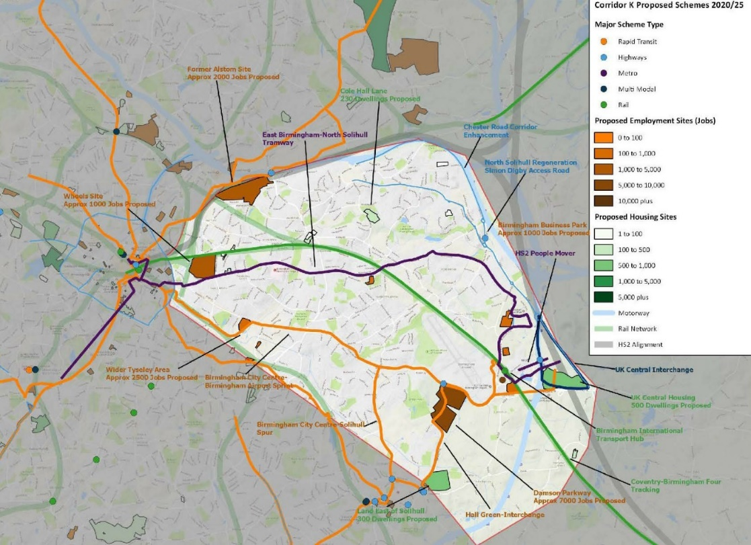

Note. The slide incorrectly records the housing expectation for the East of Solihull site as 300 whereas the correct number used in the SMBC plan is 700.

